**CODES AND PLOTS**

Link to collab:

<https://colab.research.google.com/drive/1NltiXU3vWhm2PQ01xSttmZIOOAOPUEMR?usp=sharing>

Plots;

1. P controller

Kp =5

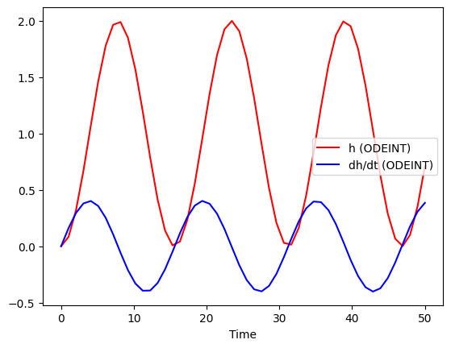

Kp = 15

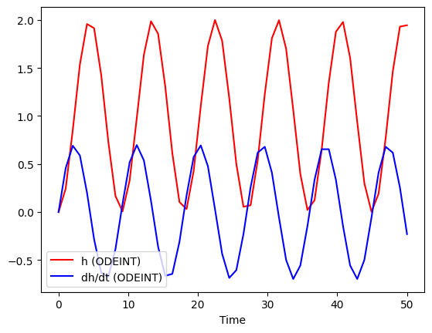

Kp = 50

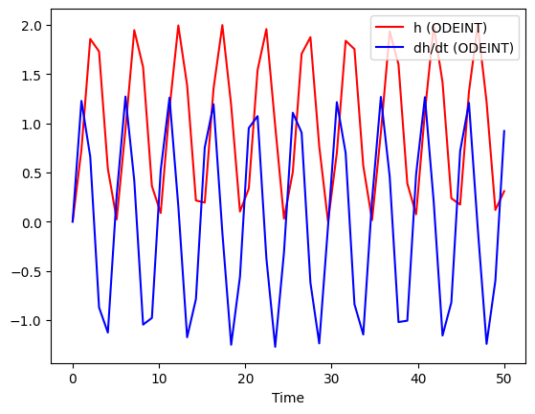

1. PD Controller – Under Damped

Kp = 100, kd = 61.6

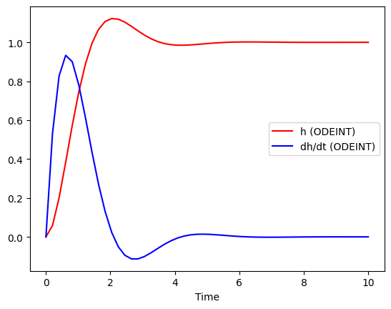

Kp = 1000, kd = 61.6

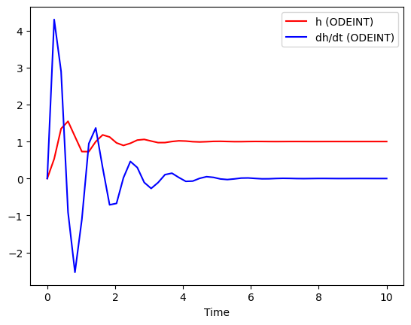

1. PD Controller – Overdamped

Kp = 5, kd = 61.6

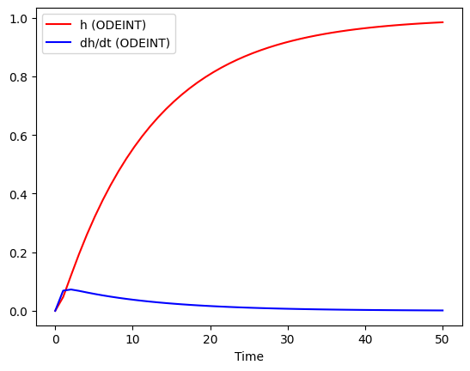

Kp = 1, kd = 61.6

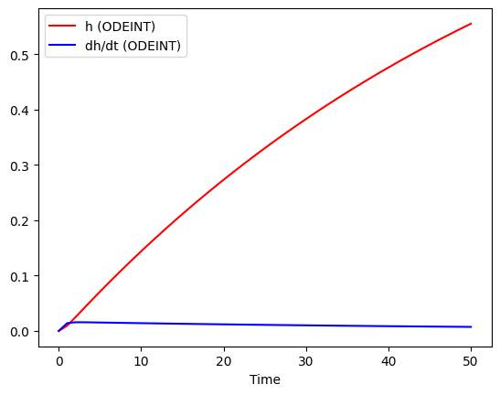

1. PD controller – Underdamped with noice ( u’ = 0.95 u)

Kp = 100, kd =64.84

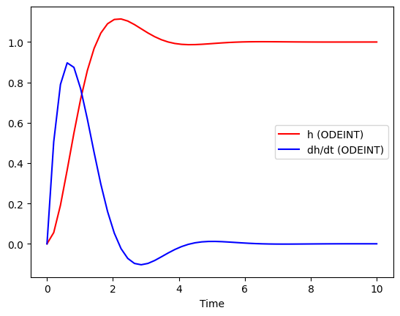

kp = 100, kd = 64.84, ki = 10

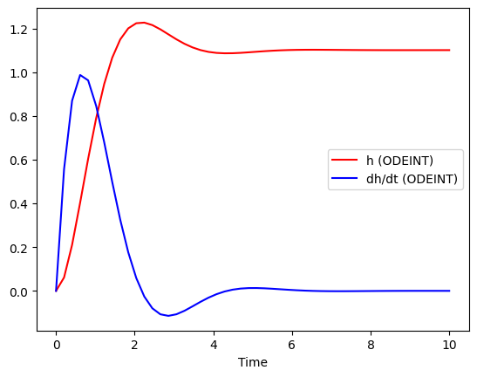

kp = 100, kd = 64.84, ki = 100

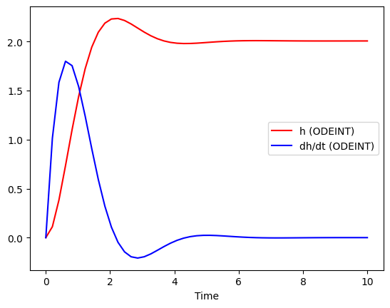

Question 3:

Plot of v(x)

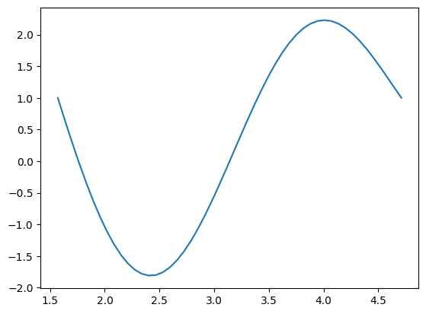

The phase portrait for the closed-loop dynamics under the control law (20)

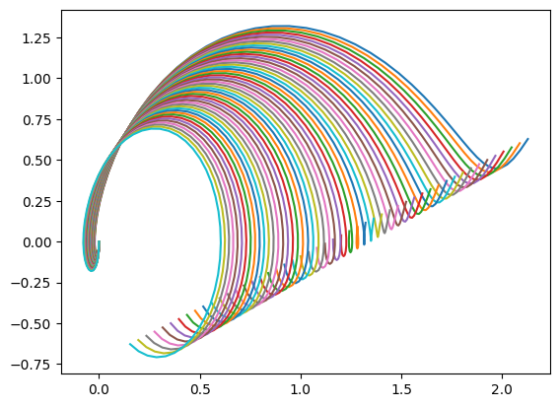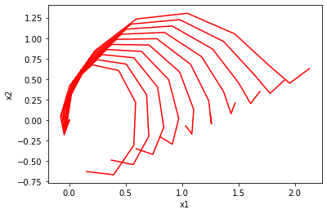

Plot the indicator function χU for the set U defined in (25);

